Paper Title

Author^{1,2}, Author^{3, *}, Author³
¹Department of Computer Science and engineering, Nanyang Technological University, Singapore
²School of Computer Engineering, Sun Yat-sen University, Guangzhou, Guangdong, China
³Shanghai Advanced Research Institute, Chinese Academy of Sciences (CAS), Shanghai, China
*Corresponding Author.

Abstract: The abstract is to be in fully-justified text as it is here, below the author information. Use the word “Abstract” as the title, in 11-point Times New Roman, boldface type, centered relative to the column, initially capitalized. The abstract is to be in 11-point, single-spaced type. Leave one blank line after the abstract, and then begin the main text. All manuscripts must be in English.

Keywords: We would like to encourage you to list your keywords in this section, separate with semicolons.

1. Introduction
Congratulations! Your paper has been accepted for journal publication. Please follow the steps outlined below when submitting your final draft to the STEMM Press. These guidelines include complete descriptions of the fonts, spacing, and related information for producing your proceedings manuscripts.

2. Formatting your Paper
All printed material, including text, illustrations, and charts, must be kept within the parameters. Please do not write or print outside of the column parameters. Margins are 2.5cm on the left side, 2.5cm on the right, 3.0cm on the top, and 2.5cm on the bottom. Paper orientation in all pages should be in portrait style.

3. Main Title
The main title (on the first page) should begin from the top edge of the page, centered, and in Times New Roman 16-point, boldface type. Capitalize the first letter of nouns, pronouns, verbs, adjectives, and adverbs; do not capitalize articles, coordinate conjunctions, or prepositions (unless the title begins with such a word). Please initially capitalize only the first word in other titles, including section titles and first, second-order headings (for example, “Titles and headings” — as in these guidelines). Leave two blank lines after the title.

4. Author Name(s) and Affiliation(s)
Author names and affiliations are to be centered beneath the title and printed in Times New Roman 11-point, non-boldface type. (See example below)

4.1 Affiliations
Affiliations are centered, italicized, not bold. Include e-mail addresses if possible.
For example:
Author^{1,2}, Author², Author³
¹Affiliation
²Affiliation
³Affiliation

4.2 Corresponding Author
Corresponding author should have an asterisk sign (*) if possible, after the corresponding author’s name. The Corresponding author (e.g., *Corresponding Author) label should be appeared at the footnote section of the first page of the paper, Times New Roman in style and 10 in font size.

5. Main Text
Type your main text in 11-point Times New Roman, single-spaced. Do not use double-spacing. Be sure your text is fully justified, flush left and flush right. Please do not place any additional blank lines between paragraphs.

5.1 Tables
Place tables as close as possible to the text they refer to and aligned center. A table is labeled Table and given a number (e.g., Table 1. Table Example) it should be numbered consecutively. The table label and caption or title appears 11pt space above the table, 11pt space after the text or paragraph if any; it should be uniforms fonts and font size, and use 11pt font size and Helvetica style, capitalized similar to paper title, aligned center and bold face. Sources and notes appear below the table, aligned left. All tables must be in portrait orientation.
For Example:
Table 1. Table Example

5.2 Figures
Place figures as close as possible to the text they refer to and aligned center. Photos, graphs, charts or diagram should be labeled Figure (do not abbreviate), and assigned a number consecutively. The label and title should be in line with the figure number (e.g., Figure 1. Figure Example), it should be uniforms fonts and font size; use 11pt font size and Helvetica style, capitalized similar to paper title, aligned center and bold face. Source (if any) appear underneath, flush left. Figures should be at good enough quality.
For Example:
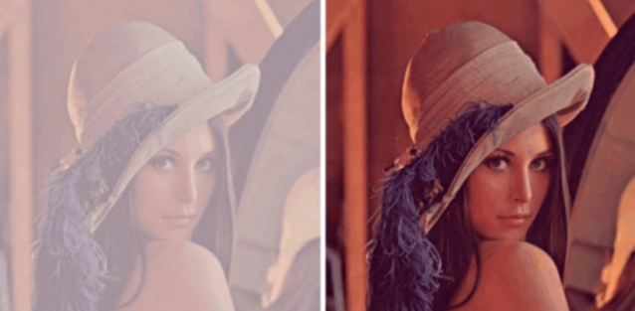
Figure 1. Figure Example

5.3 Equations
Including symbols and equations in the text, the variable name and style must be consistent with those in the equations. Equations should be indented at the left margin and numbered at the right margin, equation number is enclosed with open and close parenthesis () Time New Roman in style and 11pt font size. Deﬁne all symbols the ﬁrst time they are used. All equation symbols must be defined in a clear and understandable way.
For Example:
$E={\text{mc}}^{2}$ (1)

6. First-order Headings
For example, “1. Introduction”, should be Times New Roman 11-point boldface, initially capitalized, flush left, with one blank line before.

6.1 Second-order Headings
As in this heading, they should be Times New Roman 11-point boldface, initially capitalized, flush left, with one blank line before.

Acknowledgments
These should be brief and placed at the end of the text before the references.
For example:
This paper is supported by National Natural Science Foundation of China (No. XXX).

References
List and number all bibliographical references that has important contribution on the paper, (if possible, limit to 20, which only are necessary citations are recommended). 11-point Times New Roman, fully justified, single-spaced, at the end of your paper. When referenced in the text, enclose the citation number in square brackets, for example [1]. Don’t forget to put period (.) at the end of each reference. (See examples below)

Journal Articles
[1] Checcucci Enrico, Piramide Federico, De Cillis Sabrina, et al. Health Information Technology Usability Evaluation Scale and User-Experience Questionnaire for 3D Intraoperative Cognitive Navigation System for Urological Procedures[J]. Medicina, 2023, 59(3):624-624.

Books
[2] H. S. Nalwa. Magnetic Nanostructures[M]. American Scientific Publishers, 2003.

Conference Proceedings
[3] J. Kimura and H. Shibasaki. Recent Advances in Clinical Neurophysiology[C]. Proceedings of the 10th International Congress of EMG and Clinical Neurophysiology, Kyoto, Japan, 1995.

